

Dr. Gregory, Grimes inc.

2021-04-13

Dr. Grimes

979 Sanchez Via, Leechester, AS 06679

Phone: 7802030092

Fax: 1753777021

**Re:** Kristina, Mckinney

**PHN:** 6960118370

**Birthdate:** 27-Sep-1937

**Address:** 14405 Johnson Vista, Andersenfurt, MN 12735

**Patient number:** 9572666848

To Whom It May Concern:

This is a medical letter to state the above patient is pregnant with expected delivery date of 29-Sep-2025. Hoping this information is satisfactory for your requirements.

Thank you.

Sincerely,

Dr. Gregory, Grimes

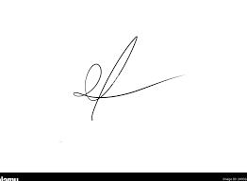

FRCS© NCMP

Clinical Assistant Professor, UBC

Department of Obstetrics and Gynecology SMH